**Lab 2 Tasks:**

1. Create a web page named as E-Learning Lecture Tutorials web page should contain Video tag and audio tag (at least 3 videos and audio). Attached the output and the code.

2. Create your Time Table. Attached the output and the code

**Lab 3 Tasks:**

1. Create the HTML form given below. Attach the Output and code

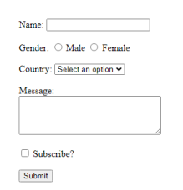

1. Create the student registration form given below. Attach the Output and code.

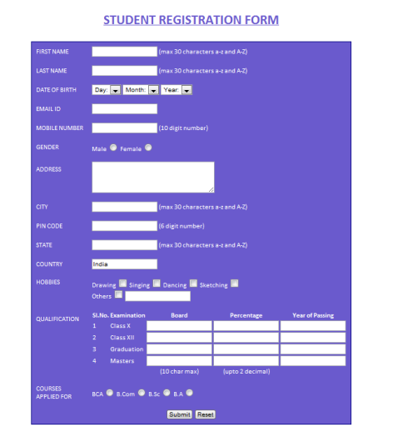

**Lab 4 Tasks:**

1. Create a basic webpage layout using HTML and CSS, following semantic HTML principles. Your layout should include the following sections:
   1. Header
   2. Navigation
   3. Main Content Area
   4. Footer
2. Create a simple portfolio page using HTML and CSS that showcases your personal work or skills. The portfolio should include a header, a main content section to showcase your work or projects, and a footer.

**Lab 5 Tasks:**

1. Create a navigation bar using HTML and CSS. Implement a hover effect on the navigation items so that the background or text color changes when the user hovers over each menu item.
2. Create three <div> elements on a webpage. Apply a **transition effect** so that when the user hovers over each <div>, the color or size changes smoothly.
3. Create three <div> elements on a webpage. Apply a **CSS animation** to each of them that activates when the user hovers over the divs. The animation will rotate the <div> and change its background color

**Lab 6 Tasks:**

1. Design and implement a simple e-store layout. The layout should display at least 9 products from the same category, a navigation bar, and support responsive design that works well on mobile, tablet, and desktop screens.

Note: Use Flexbox and grid.

**Lab 7 Tasks:**

1. Declare two variables—username and age. Assign a string value to username and a number to age. Print both values on the webpage.
2. Create an if-else statement to check whether a number (stored in a variable num) is positive, negative, or zero. Print the result accordingly.
3. Write a for loop to calculate the sum of all numbers from 1 to 100 and display the result.
4. Write a while loop that prints the values of x from 1 to 10, where each value of x is multiplied by 2.
5. Create a function that calculates the average of an array of numbers.